Logo partner insitute   | Department: Clinical Sciences | Unit: Tropical Laboratory Medicine
 | Laboratory processing of blood cultures
 | Project/study: NA

Scope and application

The patient’s blood is collected into a blood culture bottle and incubated. This SOP describes which steps are taken to correctly process an inoculated blood culture bottle in the laboratory. This SOP is written for manual (equipment-free) blood culture systems. It can be adapted to the system used and the pathogens expected.

Responsibilities

Function | Activities
Staff working with blood cultures (lab technician) | - Complies with this procedure  - Fills in the laboratory form for blood cultures

Materials
- Disposable gloves
- Labels/Pens

Procedures
4.1 At arrival of blood culture bottles in the laboratory:
- Check if the labelling of the bottle is correct:
  - Name;
  - hospital number (if available);
  - date of birth;
  - date and time of blood collection and barcode (if available) both on the request form and the blood culture bottle;
- Check if the request form is completely filled in
- Register the blood culture bottle in the laboratory sample reception logbook:
  - patient hospital number;
  - blood culture bottle number;
  - name;
  - date of birth;
  - gender;
  - date and time of reception in the lab
- Take a new laboratory form for blood cultures for each blood culture bottle
  - Generate a blood culture set N° and a blood culture bottle ID for each blood culture bottle
  - Record the patient’s hospital number (if available) and blood culture number on the form
  - Record the date and time of reception of the blood culture bottle at the laboratory
  - Indicate if it is a paediatric or adult blood culture bottle
  - Indicate if it is an aerobic or anaerobic blood culture bottle
- Check the bottle for damage, expiry date and correct use (see Annex 1 for examples); write any comments on the laboratory form
- Weigh the bottle
  - Record both weights (before and after) on the laboratory form for blood cultures
- Inspect the bottle for signs of growth (see section 4.2.)
  - If there are signs of growth at arrival of the bottle in the lab, process the bottle as grown blood culture (procedure described under TLM_PRO_109 “Work up of grown blood cultures”)
- When the request form indicates clinical suspicion of Brucella, mark this clearly on the bottle. Refer to Annex 2 in case of suspicion of Brucella.
- Place the bottle in the incubator
- Record the date and time of entry of the blood culture bottle into the incubator on the laboratory form
- When available, record the results of the malaria diagnostic tests onto the laboratory form
- For each blood culture bottle, follow each day the steps as explained in Table 1. Refer to annex 3 for explanation for choice of day of incubation.

Table 1: Actions by day of incubation (not for suspicion of Brucella)

Day of incubation | Comment | Inspection/action
0 | Day of reception of the bottle | Inspect for signs of growth at arrival of the bottle in the lab; if arrival in the morning, check again in the afternoon
1 | After overnight incubation | Morning: inspect for signs of growth  Afternoon: inspect for signs of growth
2 | After 2x overnight incubation | Morning: inspect for signs of growth  Afternoon: inspect for signs of growth
3 | After 3x overnight incubation | Morning: inspect for signs of growth
4 | After 4x overnight incubation | Morning: inspect for signs of growth
5 | After 5x overnight incubation | Morning: inspect for signs of growth
6 | After 6x overnight incubation | Morning: inspect for signs of growth
7 | After 7x overnight incubation | Morning: inspect for signs of growth; if no signs of growth: See section 4.3 C

4.2 Visual inspection of blood culture bottles:

- Always inspect the blood culture bottles against a light source (such as a lightbox)
- Inspect the bottles in the morning and the afternoon for the first three days of incubation (see Table 1)
- Thereafter, inspect once daily until day 7 of incubation (unless suspicion of Brucella: in that case inspect daily until day 30 of incubation, see Annex 2)

Signs of growth:
- Turbidity
- Haemolysis
- Colour changes
- Gas production
- Pellicle (film) formation (see Figure 1)
- Clotting
- Visible colonies, “puff balls”
- In case of biphasic bottle: colony growth on the solid agar
- In case of BacT/ALERT bottles (bioMérieux): colour change of the indicator at the bottom of the bottle (see Figure 2)

Figure 1: Film at the surface of the blood culture bottle in Pseudomonas aeruginosa infection

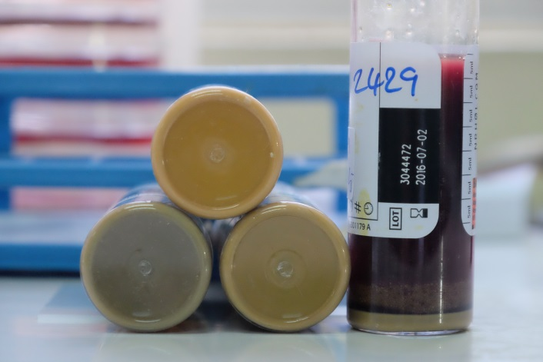

Figure 2: colour change of the indicator at the bottom of BacT/ALERT bottles: the top bottle shows signs of growth (colour change to yellow)

4.3 Daily processing of blood culture bottles

- Bottle shows signs of growth
If a bottle shows signs of growth, proceed with TLM_PRO_109 “Work up of grown blood cultures”.

- Bottle shows no signs of growth on day 7 of incubation
Report all bottles which show no growth on day 7 as “no growth” to the clinician (except in case of prolonged incubation for suspicion of Brucella, see Annex 2) and discard the bottle

Note: Terminal subculture

Performing a subculture on day 7 for bottles showing no signs of growth (terminal subculture) is not recommended. Only in the following circumstances it can be considered:
- As part of a validation study of a blood culture system, to assess whether grown blood cultures were missed
- In case of prolonged incubation (e.g. suspicion of Brucella), before discarding the bottle on day 30

Bibliography

- “Essential procedures for Clinical Microbiology”. Henry D. Isenberg. 1998 American Society for Microbiology, Washington DC.
- Reimer GL et al. Update on detection of bacteremia and fungemia. Clin Microbiol Rev. 1997; 10(3): 444-465
- Bruins et al. Does electronic clinical microbiology results reporting influence medical decision making: a pre- and post-interview study of medical specialists. BMC Med Inf & Decision Making. 2011;11:19
- Yagupski P. Detection of Brucellae in blood culture. J Clin Microbiol. 1999:37(11):3437–3442

Appendices & Forms for completion
Number | Title
None

Revision
TLM_PRO_108 Version 1.1 | Initial version
Version 1.2 – 06/09/2018 | Day of incubation is adapted: Day 0 is set as the day of reception, Day 1 as after overnight incubation.

Name and function | Date | Comment
Author
Sien Ombelet | 07/08/2017  07/08/2018 | Latest revision 10/01/2019
Reviewed by
Barbara Barbé  Jan Jacobs | 09/08/2017  09/08/2017
Approved by
Jan Jacobs | 26/01/2018 | Refer to mail BB 26/01/2018

Annex 1: Possible problems with the blood culture bottle upon arrival
- Expiry date exceeded
- Visible damage of the bottle (e.g. leak)
- Only one bottle instead of two (for adult)
- Use of an adult bottle for a child’s blood culture
- Barcode or label removed
- Too full

Annex 2: Suspicion of Brucella

In case of clinical suspicion of Brucella, prolonged incubation and inoculation of a biphasic bottle is required.
- Clearly mark the bottle with a label saying “Brucella”
- Incubate the blood culture bottle for a total of 30 days (day 1 = day of reception). Check for signs of growth daily as described above.
- Send a biphasic bottle (Castaneda or Hemoline) bottle to the ward; phone the ward and tell the clinician or nurse to sample another 10 ml of blood for this patient and inoculate it into the biphasic bottle.
- At arrival of the inoculated biphasic bottle in the lab, tilt the bottle sideways and put it on the bench for 15 minutes so that the liquid flows over the solid medium, then incubate the bottle in an upright position.
- Examine the bottle every morning:
  - In case of growth of colonies on the agar or signs of growth in broth: perform subculture (see TLM_PRO_109_v01_Work up of grown blood cultures)
  - In case of absence of colonies or other signs of growth: tilt the bottles again for 15 minutes and re-incubate in an upright position
- If there are signs of growth or colonies on the agar in any of the bottles marked with “Brucella” or the biphasic bottle:
  - Proceed with TLM_PRO_109 “Work up of grown blood cultures”
  - Take extra precautions when working with samples suspected of Brucella (see also TLM_RD_004 “Biosafety level guidelines”):
    - Use biosafety cabinet if available
    - If no biosafety cabinet available: use disposable gloves, (surgical) mask and safety goggles or face shield (PPE)
    - Put the disposable gloves and cultures for waste in an autoclavable plastic bag. Autoclave this bag, then dispose it as infectious waste.
    - Only use disposable (plastic) loops, not metal loops and no bunsen burner
- If there are no signs of growth in the broth or on the solid agar on day 30 of incubation, discard the blood culture bottles and report as “no growth”.

Annex 3: Definition of days of incubation.
